**INDUS VALLEY CIVILIZATION (IVC) SEALS USING CNN**

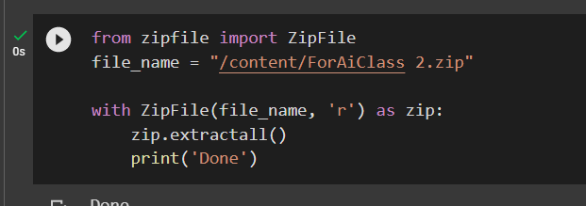

**Figure 1: Unzip the zip file**

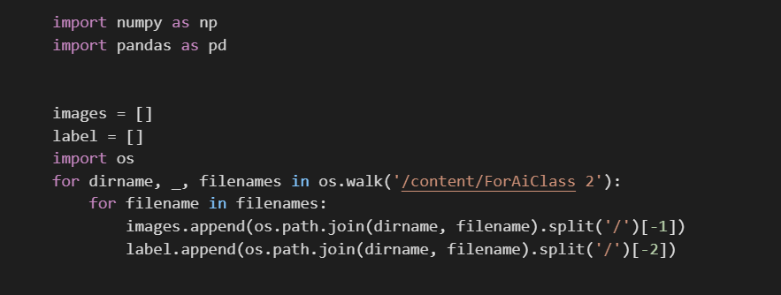

**Figure 2: Load the dataset**

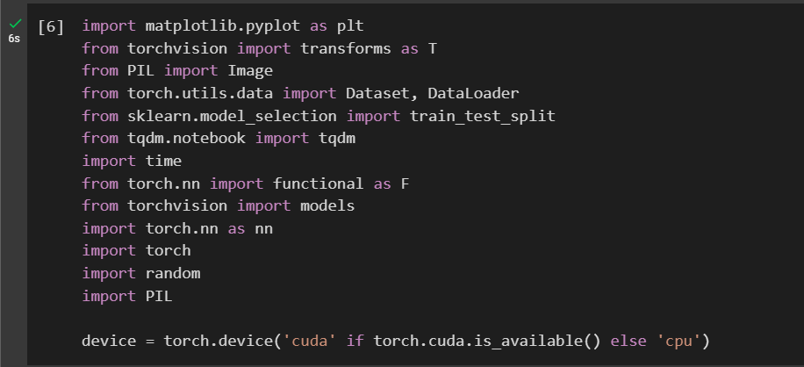

**Figure 3: Importing libraries**



**Figure 4: Print os**

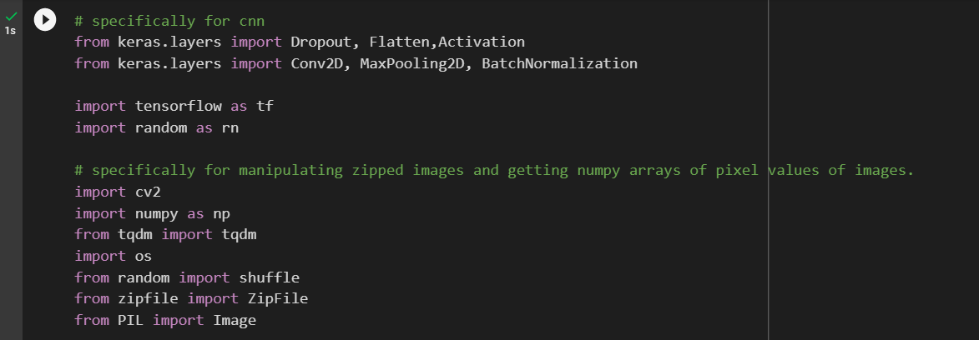

**Figure 5: CNN libraries**

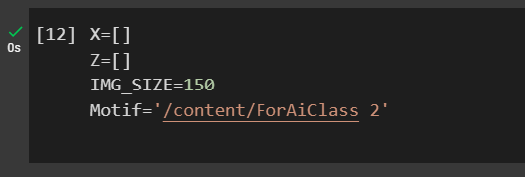

**Figure 6: Image size configuration**

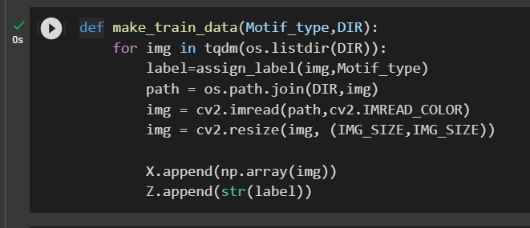

**Figure 7: Train data configuration**

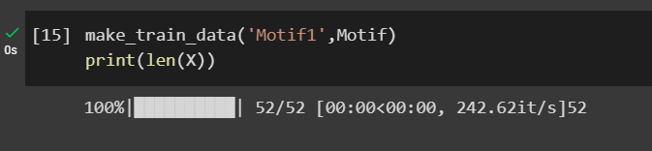

**Figure 8: Length(x)**

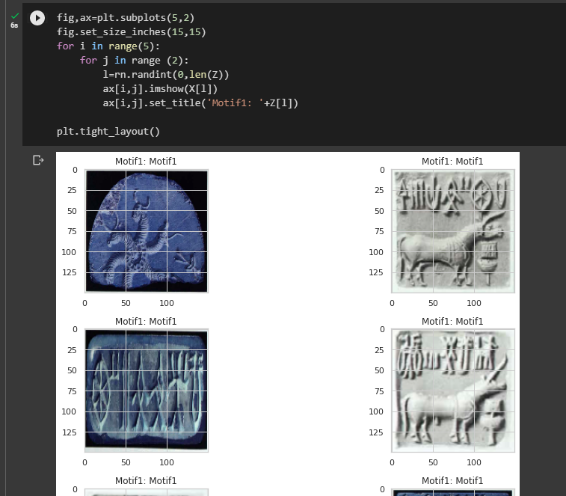

**Figure 9: Visualizing the motifs**

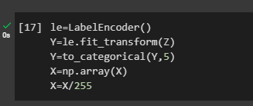

**Figure 10: Level encoding**

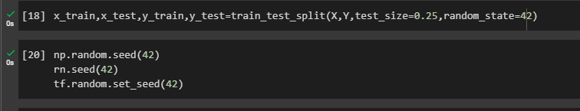

**Figure 11: Train, test split**

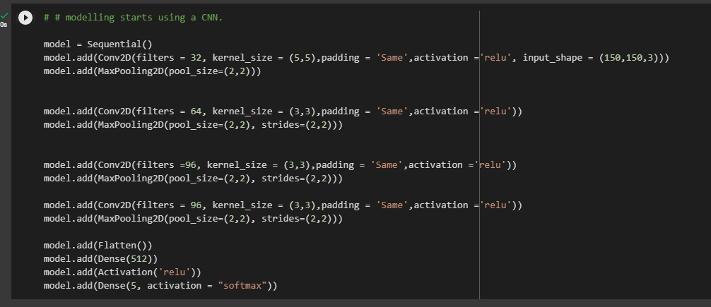

**Figure 11: CNN sequential model**

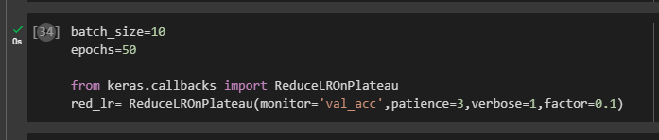

**Figure 12: Batch size**

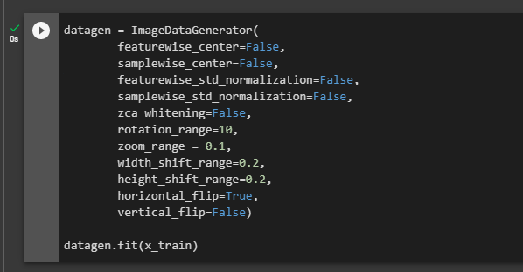

**Figure 13: Image data generator**

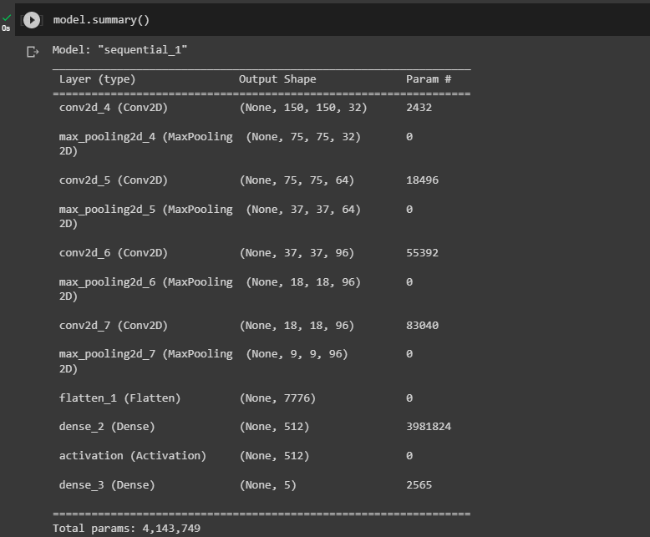

**Figure 13: Model summary**

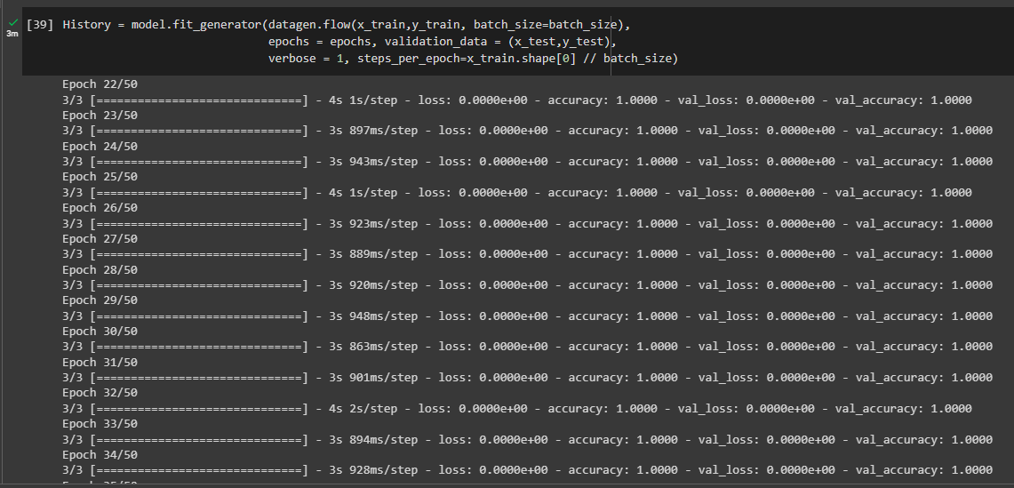

**Figure 14: Model history**

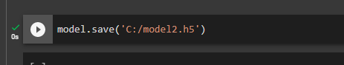

**Figure 14: Saving the Model history**

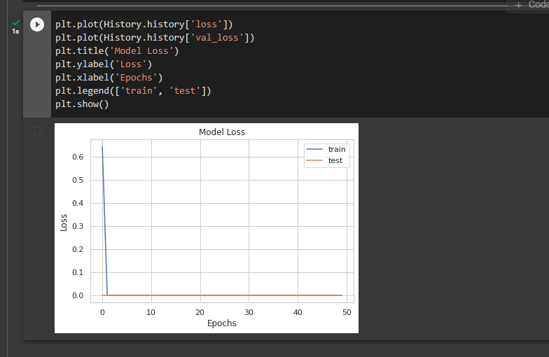 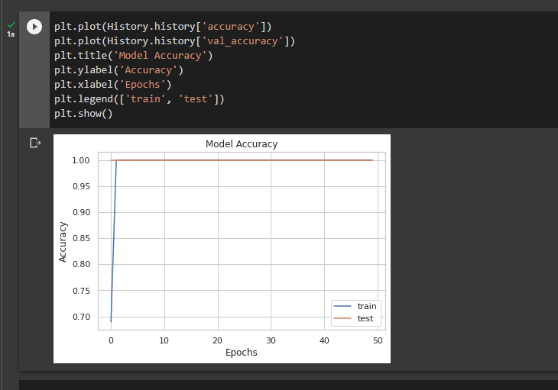

**Figure 15: Model performance evaluation**

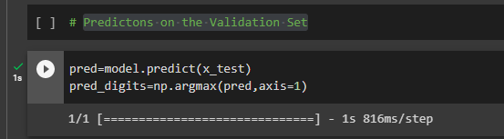

**Figure 15: Validation set prediction**

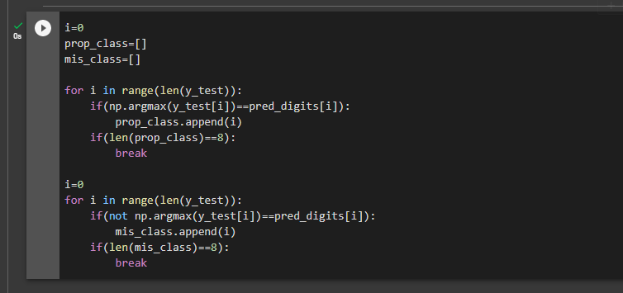

**Figure 16: Misclassified indexes**

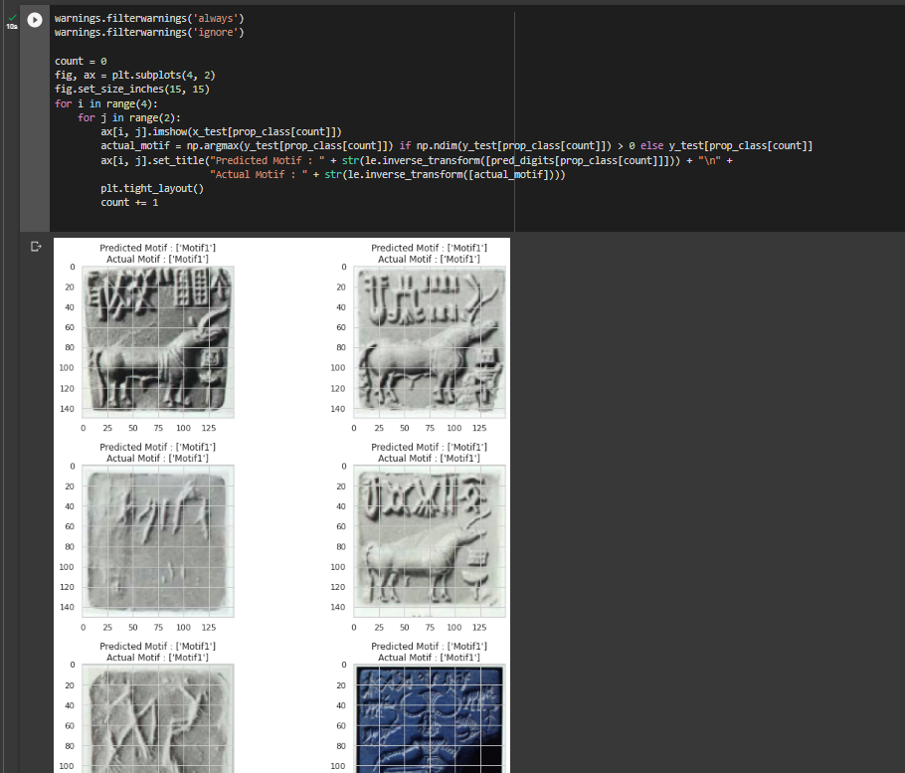

**Figure 17: Predicted vs actual motif**

**­**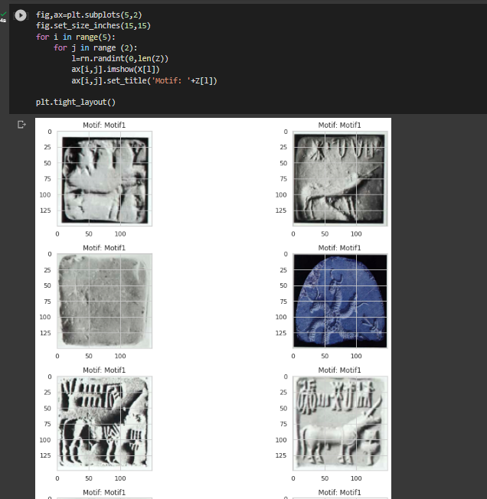

**Figure 18: Visualizing the layout**